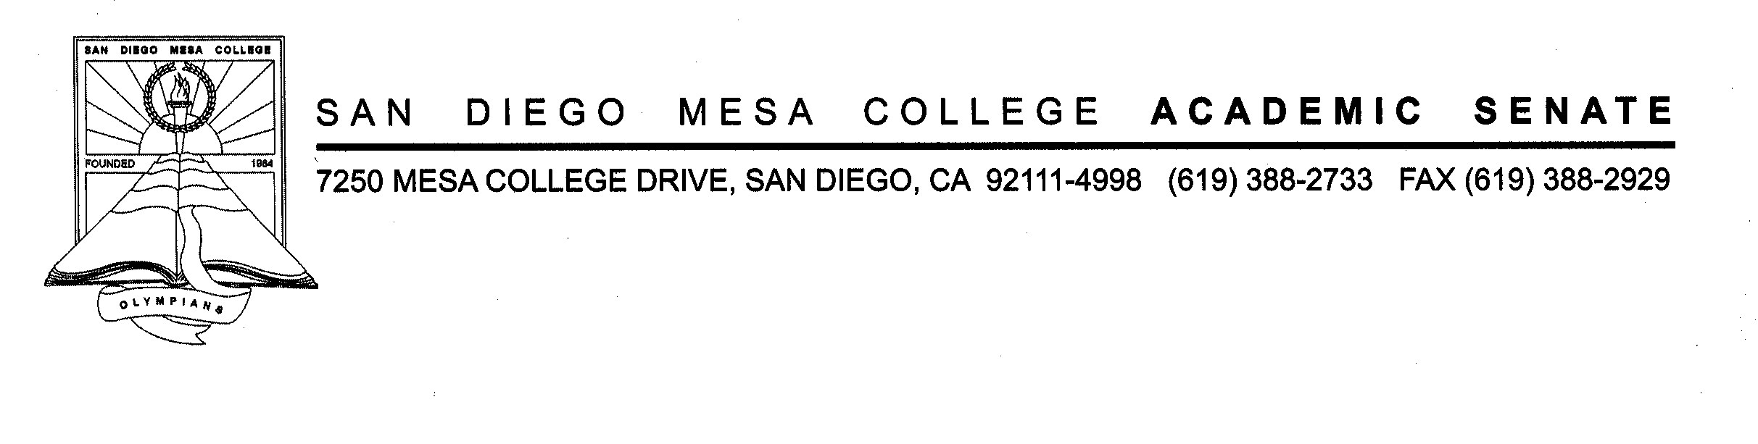
San Diego Mesa College
Academic Senate
Committee of Chairs
Room LRC 435 & Zoom
November 9, 2022
2:30PM – 4:00PM
AGENDA
SECOND DRAFT

- CALL TO ORDER AND WELCOM by Chair of Chairs Jill Moreno Ikari:

- APPROVAL OF DRAFT AGENDA:

- GUESTs:
  - Robyn Bolden & Jordan Nash - Black Student Success Fellows Program:
  - Dean Brian Weston - The CA Virtual Campus (CVC) and OEI:

- APPROVAL OF DRAFT MINUTES: October 26, 2022

- OLD BUSINESS:
  - Californian Virtual Campus (CVC): Moreno Ikari

- NEW BUSINESS:
  - San Diego Mesa College “Hot Spot” Locations: Moreno Ikari

- DEPARTMENT REPORTS:

- PLANNING/COMMITTEE REPORTS:
  - Academic Affairs: Gwin
  - Academic Senate: Crocitti
  - Curriculum Review Committee (CRC): Resch
  - Student Services: Dougherty/Higginbotham/Rico
  - Mesa College Facilities Committee/District Review of Services Committee:
  - Enrollment Management and Instructional Strategic Planning Workgroup: Budzynski
  - Planning & Institutional Effectiveness (PIE) Committee: Crocitti/Moreno Ikari
  - President’s Cabinet: Crocitti/Moreno Ikari
  - Program Review Committee (PRC): Miyoshi
  - Mesa Pathways Committee: Alioto/Eskew

- ANNOUNCEMENTS/ROUND TABLE/FOR THE GOOD OF THE ORDER:

- NEXT COC MEETING: November 30, 2022 – MC 211 A/B & Zoom (Fall 2022 CoC Meeting Schedule)

- ADJOURNMENT:

